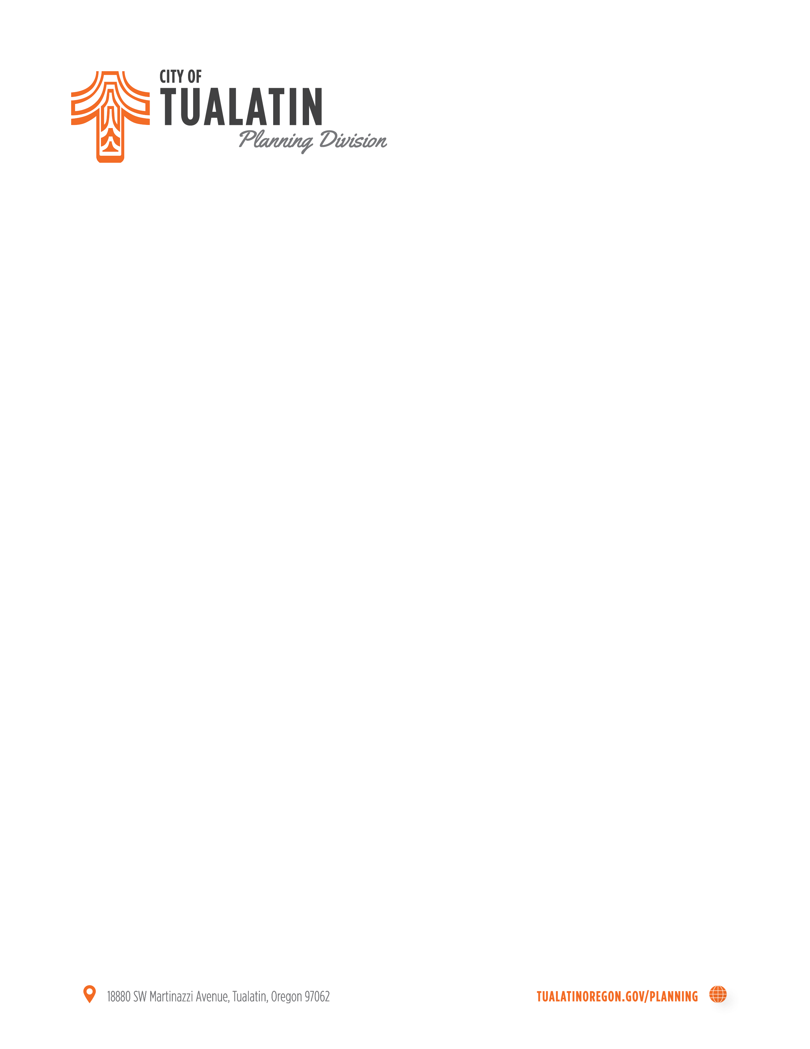
NOTICE OF DECISION
On April 27, 2020 the City of Tualatin approved with conditions AR 20-0001 for LAM Building D Addition, 11361 SW Leveton Drive, Tualatin, OR; 2S122AB Lot: 00100

This staff level decision will be final after 14 calendar days from the date of this mailing unless a written request for review is received by the Community Development Department – Planning Division at 18880 SW Martinazzi Avenue, Tualatin, OR 97062 before 5:00 p.m. The appeal must be submitted on the City Appeal (also known as Request for Review) form with all the information requested, as required by TDC 32.310, and signed by the appellant. Only those persons who submitted comments during the notice period may submit a request for review. The plans and appeal forms are available at: https://www.tualatinoregon.gov/sites/default/files/fileattachments/planning/page/5095/appeal_form_tualatinlanduse.pdf.
The appeal forms must include reasons, the appeal fee and meet the requirements of Section 32.310 of the Tualatin Development Code.

Date notice mailed: April 27, 2020
Date a Request for Review must be filed: May 11, 2020
File: AR 20-0001

