September 4, 2019

NOTICE OF DECISION

ARCHITECTURAL REVIEW AND PUBLIC FACILITIES DECISION

** APPROVAL WITH CONDITIONS **

Case #: AR 19-0003
Project: Mutual Materials Tualatin
Location: 10700 SW Tualatin-Sherwood Road; Tax lot: 2S1 27AA 02100
Applicant: Suzannah Stanley, Mackenzie: 503-224-9560
Owner: Kimberly Eiring, Mutual Materials

On September 4, 2019 the City of Tualatin approved with conditions the Architectural Review and Public Facilities Decision for AR 19-0003: Mutual Materials Tualatin to construct a 4,200 SF office/showroom and 11,700 SF storage building for the wholesale sales of bricks and pavers on a five acre property.
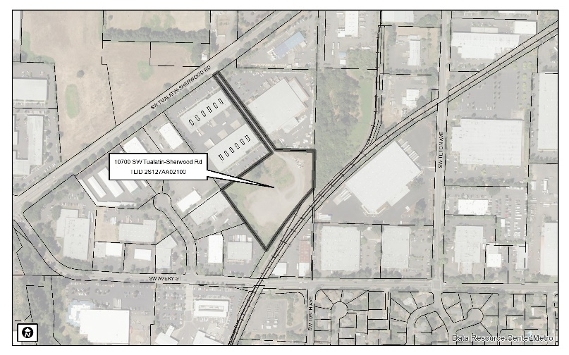
A copy of the decision and case file is available at tualatinoregon.gov/projects and available for review at 18880 SW Martinazzi Ave. Tualatin, OR 97062.
This staff level decision will be final after 14 calendar days from the date of this mailing unless a written request for review is received by the Community Development Department – Planning Division at 18880 SW Martinazzi Avenue, Tualatin, OR 97062 before 5:00 p.m. The appeal must be submitted on the City Request for Review (i.e. Appeal) form with all the information requested, as required by TDC 32.310, and signed by the appellant. Only those persons who submitted comments during the notice period may submit a request for review. The plans and appeal forms are available at the Planning Counter. The appeal forms must include reasons, the appeal fee and meet the requirements of Section 31.076 of the Tualatin Development Code.

Date notice mailed: September 4, 2019
Date a Request for Review must be filed: September 18, 2019

File: AR 19-0003

