Report Accompanying the
Leveton Tax Increment Plan DRAFT

City Council/ Tualatin Development Commission
Mayor / Chair
Frank Bubenik
City Council / Commissioners
Nancy Grimes, Council President
Maria Reyes
Christen Sacco
Bridget Brooks
Cyndy Hillier
Valerie Pratt
Planning Commission
Bill Beers, Chair
Alan Aplin
Mona St. Clair
Daniel Bachhuber
Ursula Kuhn

City of Tualatin Staff
Sherilyn Lombos, City Manager
Don Hudson, Assistant City Manager/Finance Director
Jonathan Taylor, Economic Development Manager
Kim McMillian, Community Development Director
Steve Koper, Assistant Community Development Director/Planning Manager

Elaine Howard Consulting, LLC
Elaine Howard, Scott Vanden Bos

Table of Contents
I. Introduction 1
II. The Projects in the ArEa AND THE Relationship Between Urban Renewal Projects and the Existing Conditions in the Urban Renewal Area 6
III. The Estimated Total Cost of Each Project and the Sources of Moneys to Pay Such Costs 7
IV. Financial Analysis of the Plan 7
V. The Estimated Amount of Tax Increment Revenues Required and the Anticipated Year in Which Indebtedness Will Be Retired 7
VI. The Anticipated Completion Date for Each Project 7
VII. Revenue Sharing 8
VIII. Impact of the Tax Increment Financing 8
IX. Compliance With Statutory Limits on Assessed Value and Size of Urban Renewal Area 8
X. Existing Physical, Social, and Economic Conditions and Impacts on Municipal Services 9
XI. Reasons for Selection of Each Urban Renewal Area in the Plan 13
XII. Relocation report 13

- Introduction
The Report Accompanying the Leveton Tax Increment Plan (Report) contains background information and project details that pertain to the Leveton Tax Increment Plan (Plan). The Report is not a legal part of the Plan but is intended to provide public information and support the findings made by the Tualatin City Council as part of the approval of the Plan.
The Report provides the analysis required to meet the standards of ORS 457.087, including financial feasibility. The Report accompanying the Plan contains the information required by ORS 457.087, including:
- A description of the physical, social, and economic conditions in the area and expected impact of the plan, including fiscal impact in light of increased services; (ORS 457.087(1))
- Reasons for selection of the plan Area; (ORS 457.087(2))
- The relationship between each project to be undertaken and the existing conditions; (ORS 457.087(3))
- The estimated total cost of each project and the source of funds to pay such costs; (ORS 457.087(4))
- The estimated completion date of each project; (ORS 457.087(5))
- The estimated amount of funds required in the Area and the anticipated year in which the debt will be retired; (ORS 457.087(6))
- A financial analysis of the plan; (ORS 457.087(7))
- A fiscal impact statement that estimates the impact of tax increment financing (TIF) upon all entities levying taxes upon property in the urban renewal area; (ORS 457.087(8))
- A relocation report. (ORS 457.087(9))

The relationship of the sections of the Report and the ORS 457.087 requirements is shown in Table 1. The specific reference in the table below is the section of this Report that most addresses the statutory reference. There may be other sections of the Report that also address the statute.
Table 1 - Statutory References
Statutory Requirement | Report Section
ORS 457.087 (1) | X
ORS 457.087 (2) | XI
ORS 457.087 (3) | II
ORS 457.087 (4) | III
ORS 457.087 (5) | VI
ORS 457.087 (6) | IV,V
ORS 457.087 (7) | IV,V
ORS 457.087 (8) | VIII
ORS 457.087 (9) | XII
The Report provides guidance on how the Plan might be implemented. As the Tualatin Development Commission (TDC) reviews revenues and potential projects each year, it has the authority to make adjustments to the implementation assumptions in this Report. The TDC may allocate budgets differently, adjust the timing of the projects, decide to incur debt at different timeframes than projected in this Report, and make other adjustments to the financials as determined by the TDC. The TDC may also make changes as allowed in the Amendments section of the Plan. These adjustments must stay within the confines of the overall maximum indebtedness of the Plan.
Figure 1- Leveton Tax Incement District Boundary Expansion
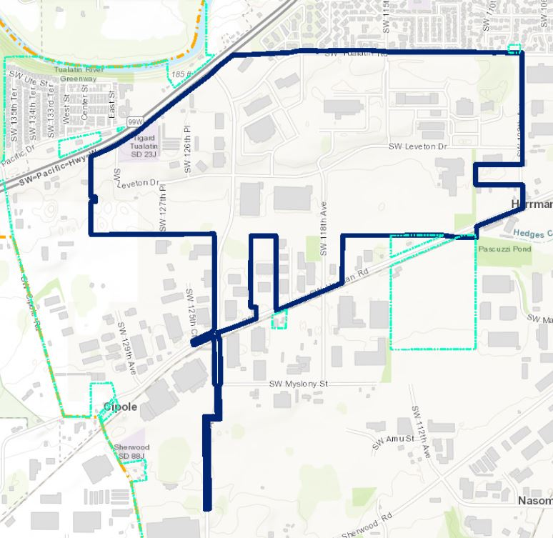

Figure 2- Leveton Tax Incement District Boundary Expansion
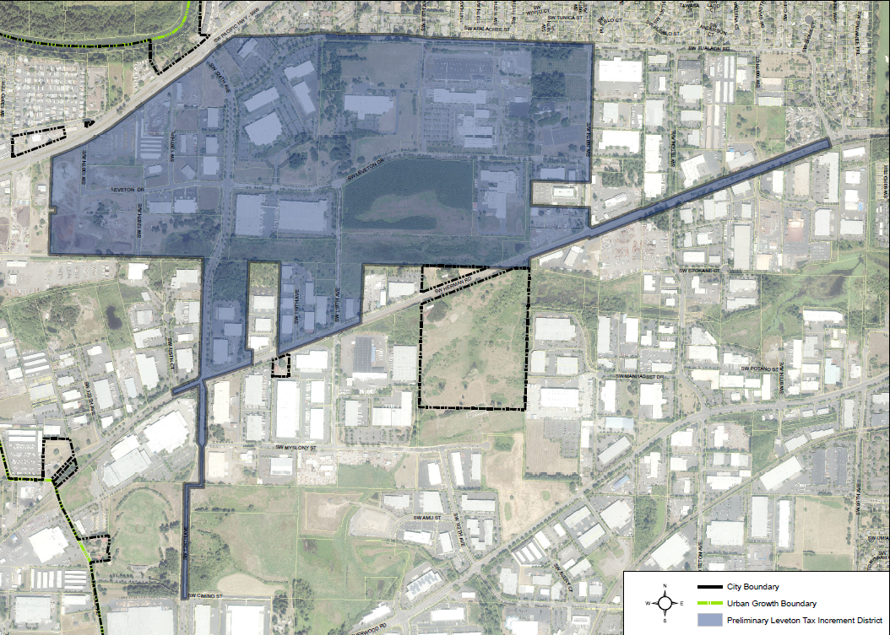

- The Projects in the ArEa AND THE Relationship Between Urban Renewal Projects and the Existing Conditions in the Urban Renewal Area
The projects identified for the Area in the 2021 Substantial Amendment are described below, including how they relate to the existing conditions in the Area.
  - Transportation

The following information for the Herman Road project to widen from Tualatin Road to Teton Road comes from the CIP, p 124.
DESCRIPTION:
Improve bike lanes, sidewalks, and transit stops along Herman Road between the employment district, neighborhoods, and downtown. Improve safety and mobility for all roadway users along Herman Road where currently, bicycles, pedestrians, automobiles, transit, and trucks share two 12-foot vehicle travel lanes because there are no bike lanes or sidewalks. Add buffered bike lanes and other “Active Transportation” components where there are existing sidewalks and bike lanes.

PROJECT SCOPE:
The total project cost includes project development, engineering, environmental permitting, right of way acquisition and construction.

EXISTING CONDITIONS/HISTORY:
This project will enable pedestrians and bicyclist to travel in a safer environment than they currently do when sharing two 12-foot travel lanes with cars, trucks, and buses. Adding sidewalks and bike lanes where they do not currently exist and providing buffered bikes lanes along the rest of the corridor will provide a safer more comfortable environment.

- The Estimated Total Cost of Each Project and the Sources of Moneys to Pay Such Costs
The total cost estimate for the Herman Road project is shown in Table 2 below. This estimate is from the City of Tualatin Capital Improvement Plan (p 103). The portion of this projects paid for by urban renewal must fit within the remaining maximum indebtedness and funds remaining in the Leveton Project Fund.
Table 2 - Estimated Cost of Each Project as Compared to Total Cost

Project Title | Total Estimated Cost from CIP
Herman Road Extension | FY 2023/24 $780,000
 | FY 2024/25 $2,415,000
Source: City of Tualatin

- Financial Analysis of the Plan
The TDC has approved a budget to allow for the completion of the projects using existing funding in the Leveton Project Fund. There will be no new impacts on taxing districts and no need to borrow additional funds to complete this project. The budget for FY 21-22 for the Leveton Projects Fund has $3,391,810 in resources and $3,391,810 in expenditures including $3,010,000 for the Herman Road project.
- The Estimated Amount of Tax Increment Revenues Required and the Anticipated Year in Which Indebtedness Will Be Retired

The Area terminated taking division of tax revenues from the Washington County Assessor in FY 2010. There are still remaining funds in the Leveton Projects Fund. The $3,195,000 of revenues required for the Herman Road project are not new tax increment revenues, but revenues within the Leveton Projects Fund. The budget for FY 21-22 for the Leveton Projects Fund has $3,391,810 on resources and $3,391,810 in expenditures including $3,010,000 for the Herman Road project. There are no existing long term indebtedness commitments in the Area.

- The Anticipated Completion Date for Each Project
Estimated completion dates for the project is in FY 2022/2023.
The TDC may change the completion dates in their annual budgeting process or as project decisions are made in administering the Plan.
- Revenue Sharing
Since the URA is no longer taking division of tax revenues, there is no revenue sharing for this URA.
- Impact of the Tax Increment Financing
The impact of tax increment financing on overlapping taxing districts is not relevant to this Amendment. The Leveton Tax Increment District is no longer taking division of taxes. If this project is not pursued, these funds could be used for other specified urban renewal projects.
- Compliance With Statutory Limits on Assessed Value and Size of Urban Renewal Area
State law limits the percentage of both a municipality’s total assessed value and the total land area that can be contained in an urban renewal area at the time of its establishment to 25% for municipalities under 50,000 in population. This limitation pertains to urban renewal areas that are taking division of tax revenues as stipulated in ORS 457.420(2)(b)(A). This urban renewal area is no longer taking division of tax revenues. The City is considering another urban renewal area, and the report on that urban renewal area will address relevant compliance with statutory limits on assessed value and acreage.

- Existing Physical, Social, and Economic Conditions and Impacts on Municipal Services
This section of the Report describes existing conditions within the Leveton Tax Increment District and documents the occurrence of “blighted areas,” as defined by ORS 457.010(1).
  - Physical Conditions

1. Land Use
The Area is composed of 57 individual parcels encompassing 351.16 acres in parcels. The City of Tualatin database was used to determine the land use designation of parcels in the Area. Thirteen of the parcels are classified as non-profit or government uses and are tax exempt. By acreage, Commercial uses account for the most prevalent land use within the Area (53.18%). This was followed by Industrial uses (32.22%). Detailed land use designations in the Area can be seen in Table 3.
Table 3 - Land Use in the Area

Land Use | Parcels | Acreage | Percent of Acreage
Commercial | 36 | 186.74 | 53.18%
Industrial | 7 | 113.13 | 32.22%
Exempt | 11 | 35.84 | 10.20%
Multi-Family | 1 | 10.21 | 2.91%
Miscellaneous | 2 | 5.24 | 1.49%
TOTAL: | 57 | 351.16 | 100%
Source: Compiled by Elaine Howard Consulting, LLC with data from the City of Tualatin

2. Comprehensive Plan and Zoning Designations
In Tualatin, there is a one map system. The most prevalent comprehensive plan designation by acreage in the Area is Manufacturing Park (69.96%). The second most prevalent comprehensive plan designation in the Area is Light Manufacturing (18.51%). Detailed comprehensive plan designations in the Area can be seen in Table 4 – Comprehensive Plan and Zoning Designations in the Area.
Table 4 – Comprehensive Plan and Zoning Designations in the Area
Comprehensive Plan | Parcels | Acreage | Percent of Acreage
Manufacturing Park | 24 | 245.66 | 69.96%
Light Manufacturing | 21 | 64.99 | 18.51%
General Manufacturing | 10 | 23.11 | 6.58%
General Commercial | 2 | 17.40 | 4.96%
TOTAL: | 57 | 351.16 | 100%
Source: Compiled by Elaine Howard Consulting, LLC with data from the City of Tualatin

  - Infrastructure
This section identifies the existing conditions in the Area to assist in establishing blight in the ordinance adopting the Tax Increment Plan. The blighting condition is the “the existences of inadequate streets and other rights of way, open spaces and utilities” (ORS457.010 (1)(e).

1. Transportation
The City of Tualatin Capital Improvement Plan has identified the Herman Road Extension project as a needed improvement. (CIP p 124)

DESCRIPTION:
Improve bike lanes, sidewalks, and transit stops along Herman Road between the employment district, neighborhoods, and downtown. Improve safety and mobility for all roadway users along Herman Road where currently, bicycles, pedestrians,
automobiles, transit, and trucks share two 12-foot vehicle travel lanes because there are no bike lanes or sidewalks. Add buffered bike lanes and other Active Transportation components where there are existing sidewalks and bike lanes.

PROJECT SCOPE:
The total project cost includes project development, engineering, environmental permitting, right of way acquisition and construction.

EXISTING CONDITIONS/HISTORY:
This project will enable pedestrians and bicyclist to travel in a safer environment than they currently do when sharing two 12-foot travel lanes with cars, trucks, and buses. Adding sidewalks and bike lanes where they do not currently exist and providing buffered bikes lanes along the rest of the corridor will provide a safer more comfortable environment.

  - Social Conditions
There is only one lot with residential use in the Area. The area is an employment area for the City of Tualatin providing 7,500 jobs with an average wage of $98,000.
  - Economic Conditions

1. Building to Land Value Ratio
An analysis of property values can be used to evaluate the economic condition of real estate investments in a given area. The relationship of a property’s improvement value (the value of buildings and other improvements to the property) to its land value is generally an accurate indicator of the condition of real estate investments. This relationship is referred to as the “Improvement to Land Value Ratio," or “I:L.” The values used are real market values. In urban renewal areas, the I:L is often used to measure the intensity of development or the extent to which an area has achieved its short- and long-term development objectives.
Table 5 shows the improvement to land ratios (I:L) for properties within the Area. There are 11 parcels listed as Exempt from taxation, so they have no assessed value. No improvement value means there are no taxable structures on the tax lot. Overall, the Area is significantly developed.
Table 5 - Improvement to Land Ratios in the Area

Improvement to Land (I:L) Ratio | Parcels | Acreage | Percent of Acreage
Exempt | 11 | 35.84 | 10.20
No Improvement Value | 11 | 103.98 | 29.61
0.01-0.50 | 4 | 5.98 | 1.70
0.51-1.00 | 2 | 19.35 | 5.51
1.01-1.50 | 3 | 28.79 | 8.20
1.51-2.00 | 2 | 28.68 | 8.17
2.01-2.50 | 4 | 49.38 | 14.06
2.51-3.00 | 1 | 1.06 | 0.30
3.01-4.00 | 6 | 28.66 | 8.16
> 4.00 | 13 | 49.44 | 14.08
TOTAL: | 57 | 351.16 | 100.00
Source: Compiled by Elaine Howard Consulting, LLC with data from the city of Tualatin

  - Impact on Municipal Services
There is no fiscal impact of tax increment financing on taxing districts that levy taxes within the Area (affected taxing districts) as the Area is no longer taking division of tax revenues. This subsection discusses the fiscal impacts resulting from potential increases in demand for municipal services.
The project being considered for future use of urban renewal funding is a transportation improvement project. The use of funds in the Leveton Projects Fund allows the city to add an additional funding source to the City of Tualatin general fund or system development charges funds to allow these projects to be completed.

- Reasons for Selection of Each Urban Renewal Area in the Plan
The reason for selecting the Area is to provide the ability to fund projects and programs necessary to cure blight within the Area.
- Relocation report
No relocation is expected from the added project in this amendment. If the TDC acquires occupied property under the Plan, residential or commercial occupants of such property shall be offered relocation assistance, as required under applicable state law. Prior to such acquisition, the TDC shall adopt rules and regulations, as necessary, for the administration of relocation assistance. The TDC will comply with all applicable state law in providing these potential benefits.

